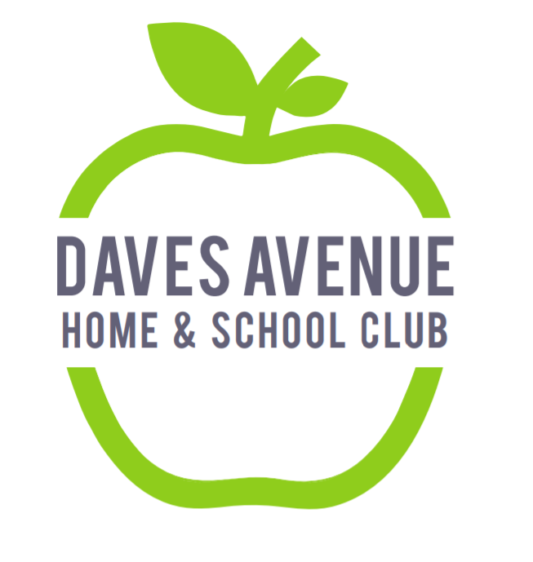

Daves Avenue Home & School Club

EXECUTIVE BOARD MEETING Minutes

Date: August 26, 2022
Location: Daves Avenue Elementary School - MPR

In attendance in person
Voting: Jenna Mittleman, Michelle Nielsen, Melissa Barragan, Diana Chiu, Alexis Barnickel, Emma Jebara, Kim Watt, Bob Lapcevic
Non-voting: Deborah Weinstein, Jennifer Shapiro, Ethan Ducker, Sarah Osmanski, Erin Vittal, Andrea Oliver, Phuong Nguyen, Angelina Randazzo, Gina Zillman, Callie Stefani

In attendance via Zoom
Voting: Jessica Johnson

- The meeting was called to order by Michelle Nielsen at 8:25am
- Approval of July 20, 2022 Executive Board Meeting Minutes.
  - Motion: Michelle
  - Second: Melissa
  - Motion Passed
- Principal’s Report – Jenna Mittleman
  - Introductory remarks on the start of school.
  - Math Specialist introduction: Ethan Ducker introduction. He described his passion for math and working closely with the previous math specialist.
- One Community Los Gatos – Deborah Weinstein and Jennifer Shapiro
  - Described new OCLG video and opportunity drawing for early donors (those who donate before September 2nd. Also sponsoring STEAM Nights at each elementary school. Reported on OCLG goals for the 2022-2023 year. OCLG is providing STEAM lessons, 17 art lessons and a Spanish pilot.
- Safe Routes 2 School – Angelina Randazzo
  - 4th Grade bike rodeo is on September 20th. Need prizes for walk/bike to school week (week of October 4th).
- Treasurers’ Report –Jessica Johnson
  - 2022-2023 budget update: Provided an update on the 2022-2023 budget and current account balances. Tax return was in process. Bob has agreed to be the Daves representative for the Financial Advisory Committee.
- Family Movie Night – Phuong Nguyen and Andrea Oliver
  - Family Movie Night will be October 14th. Decided on Sing 2 as the move for Family Movie Night. There will be food trucks, popcorn, cotton candy and will have pre-order capability.
- Presidents’ Report – Michelle Nielsen
  - Reported on Ice Cream Social, Back to School Coffee and Back to School night. The HSC shed needs to be cleaned out and will propose some dates. The Avenue will be distributed via Parent Square.
- Communications Report – Kim Watt
  - Requested an update for the open chair positions so we can update the website. Social media discussion and request for pictures of activities.
- New Business
  - Discussion on business event sponsorship. While we cannot fundraise for families during OCLG campaign, lots of families want to participate.
- Old Business
- Adjournment at 9:40am

